

# **PASHA DE CARTIER WATCH**

Product Details:

Pasha de Cartier watch, 41 mm, mechanical movement with automatic winding, calibre 1847 MC. Steel case, fluted crown cap and crown with a cabochon-shaped spinel, blue sunray-brushed dial, steel diamond-shaped hands, steel bracelet with SmartLink adjustment system, blue alligator-skin strap, interchangeable folding steel buckle.

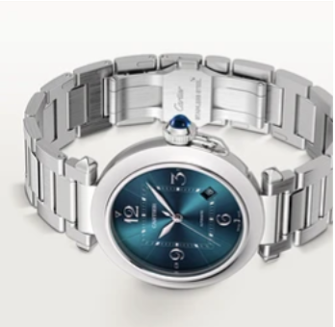Both straps are fitted with the QuickSwitch interchangeable system. Case diameter: 41 mm, thickness: 9.55 mm. Water-resistant up to 10 bar (approx. 100 metres).